Ex.No:1 CALCULATOR USING ARITHMETIC OPERATOR

Date:

AIM:
To create a calculator using arithmetic operation

ALGORITHM:
Step 1:Start the process
Step 2: Select start => Programs => Microsoft visual studio
Step 3: It opens a dialog box in that select New project icon and select windows form application & specify the file name .then click OK
Step 4: After step 3, It opens a new form along with the project. Add a textbox to read input & display the output
Step 5:Add buttons for numbers from 0 to 9,decimal point & arithmetic operators (+,-,*,/)and Equal(=)
Step 6:Add clear and End button to clear the textbox content and exit from the form
Step 7:All arithmetic operators are binary operator &perform the following operations=>’+’sign click number1(display 1 in textbox),operator(+)and then number 2 followed by click’=’sign will display the output in same text box(added result)
step 8 : Repeat step 07 for remaining operator step 9: Stop the process
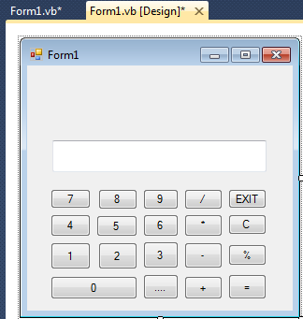

FORM DESIGN

CODING

PublicClassForm1
Dim Firstnum AsDecimal Dim Secondnum AsDecimal Dim Operations AsInteger
Dim Operator_selector AsBoolean = False

PrivateSub Button12_Click(ByVal sender As System.Object, ByVal e As System.EventArgs) Handles Button12.Click
Firstnum = TextBox1.Text TextBox1.Text = " " Operator_selector = True Operations = 1'For addition
EndSub

PrivateSub Button13_Click(ByVal sender As System.Object, ByVal e As System.EventArgs) Handles Button13.Click
Firstnum = TextBox1.Text TextBox1.Text = " " Operator_selector = True Operations = 2 'For subtraction
EndSub
PrivateSub Button14_Click(ByVal sender As System.Object, ByVal e As System.EventArgs) Handles Button14.Click
Firstnum = TextBox1.Text

TextBox1.Text = " " Operator_selector = True Operations = 3 'For multiplication
EndSub

PrivateSub Button15_Click(ByVal sender As System.Object, ByVal e As System.EventArgs) Handles Button15.Click
Firstnum = TextBox1.Text TextBox1.Text = " " Operator_selector = True Operations = 4 'For divide
EndSub
PrivateSub Button16_Click(ByVal sender As System.Object, ByVal e As System.EventArgs) Handles Button16.Click

If Operator_selector = TrueThen Secondnum = TextBox1.Text
If Operations = 1 Then
TextBox1.Text = Firstnum + Secondnum ElseIf Operations = 2 Then
TextBox1.Text = Firstnum - Secondnum ElseIf Operations = 3 Then
TextBox1.Text = Firstnum * Secondnum
Else
If Secondnum = 0 Then
TextBox1.Text = "Error!"
Else

EndIf
EndIf EndIf EndSubTextBox1.Text = Firstnum / Secondnum Operator_selector = False

PrivateSub Button11_Click(ByVal sender As System.Object, ByVal e As System.EventArgs) Handles Button11.Click
If TextBox1.Text <>"0"Then TextBox1.Text += "."
Else
TextBox1.Text = "."
EndIf
EndSub

PrivateSub Button10_Click(ByVal sender As System.Object, ByVal e As System.EventArgs) Handles Button10.Click
If TextBox1.Text <>"0"Then TextBox1.Text += "0"

Else
TextBox1.Text = "0"
EndIf
EndSub
PrivateSub Button9_Click(ByVal sender As System.Object, ByVal e As System.EventArgs) Handles Button9.Click
If TextBox1.Text <>"0"Then TextBox1.Text += "9"
Else
TextBox1.Text = "9"
EndIf
EndSub

PrivateSub Button8_Click(ByVal sender As System.Object, ByVal e As System.EventArgs) Handles Button8.Click
If TextBox1.Text <>"0"Then TextBox1.Text += "8"
Else
TextBox1.Text = "8"
EndIf
EndSub
PrivateSub Button7_Click(ByVal sender As System.Object, ByVal e As System.EventArgs) Handles Button7.Click
If TextBox1.Text <>"0"Then TextBox1.Text += "7"
Else
TextBox1.Text = "7"
EndIf
EndSub

PrivateSub Button4_Click(ByVal sender As System.Object, ByVal e As System.EventArgs) Handles Button4.Click
If TextBox1.Text <>"0"Then TextBox1.Text += "4"
Else
TextBox1.Text = "4"
EndIf
EndSub

PrivateSub Button5_Click(ByVal sender As System.Object, ByVal e As System.EventArgs) Handles Button5.Click
If TextBox1.Text <>"0"Then TextBox1.Text += "5"
Else
TextBox1.Text = "5"
EndIf
EndSub

PrivateSub Button6_Click(ByVal sender As System.Object, ByVal e As System.EventArgs) Handles Button6.Click
If TextBox1.Text <>"0"Then TextBox1.Text += "6"
Else
TextBox1.Text = "6"
EndIf
EndSub

PrivateSub Button3_Click(ByVal sender As System.Object, ByVal e As System.EventArgs) Handles Button3.Click
If TextBox1.Text <>"0"Then TextBox1.Text += "3"
Else
TextBox1.Text = "3"
EndIf
EndSub
PrivateSub Button2_Click(ByVal sender As System.Object, ByVal e As System.EventArgs) Handles Button2.Click
If TextBox1.Text <>"0"Then TextBox1.Text += "2"
Else
TextBox1.Text = "2"
EndIf
EndSub

PrivateSub Button1_Click(ByVal sender As System.Object, ByVal e As System.EventArgs) Handles Button2.Click
If TextBox1.Text <>"0"Then TextBox1.Text += "1"
Else
TextBox1.Text = "1"
EndIf
EndSub
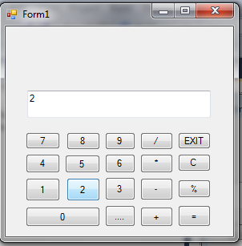
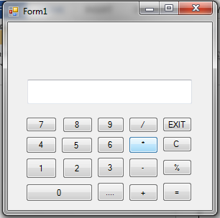
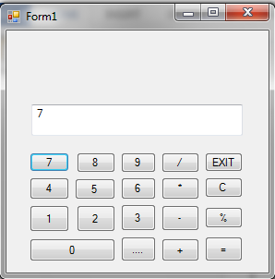
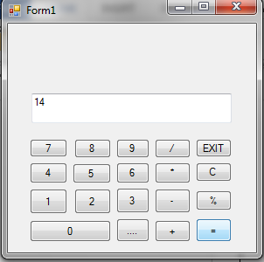

OUTPUT

Ex.No: 2 FONT APPLICATION

Date:

AIM:
To create a program for font application using validation controls

ALGORITHM:
Step01:Start the process
Step 02: Select start =>programs Microsoft visual studio
Step 03: It opens a dialog box in that select New project icon and select windows form application & specify the file name .then click OK
Step 04: After step 03 it opens a new form along with the project .In that add two textboxes for input string and displaying the output
Step 05:Then add supporting information through label for each textboxes Step 06: Add three command buttons suchas change ,clear and End
Step 07:Clicking the command button1 change the upper case lettweers to lower case letters and vice versa. And also changes the forecolor and backcolor of the textbox
Step 08: len() is used to find the length of the string.Using above function textbox1 content’s length is calculated and displayed in the textbox 2
Step 09: Clicking button 2 clears the textboxes
Step 10: Clicking the button 3 helps to exit from the application Step 11: Stop the process
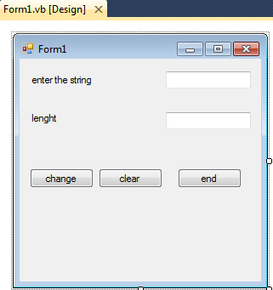

DESIGN WINDOW

CODING
PublicClassForm1

PrivateSub Label2_Leave(ByVal sender AsObject, ByVal e As System.EventArgs) Handles Label2.Leave
TextBox2.Text = Len(TextBox1.Text) EndSub
PrivateSub Button1_Click(ByVal sender As System.Object, ByVal e As System.EventArgs) Handles Button1.Click
TextBox1.BackColor = Color.Pink TextBox1.ForeColor = Color.Blue TextBox2.BackColor = Color.Cyan TextBox2.ForeColor = Color.Black
If TextBox1.Text = UCase(TextBox1.Text) Then TextBox1.Text = LCase(TextBox1.Text)
ElseIf TextBox1.Text = LCase(TextBox1.Text) Then TextBox1.Text = UCase(TextBox1.Text)
EndIf EndSub
PrivateSub TextBox1_Leave(ByVal sender AsObject, ByVal e As System.EventArgs) Handles TextBox1.Leave
TextBox2.Text = Len(TextBox1.Text)
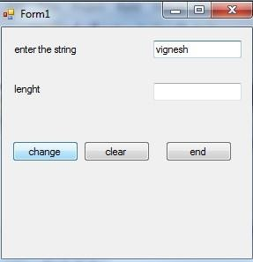
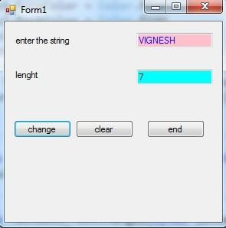

EndSub

PrivateSub Button2_Click(ByVal sender As System.Object, ByVal e As System.EventArgs) Handles Button2.Click
TextBox1.Text = " " TextBox2.Text = " "
EndSub
PrivateSub Button3_Click(ByVal sender As System.Object, ByVal e As System.EventArgs) Handles Button3.Click
End EndSub

EndClass

OUTPUT

Ex.No: 3 SUPPLIER INFORMATION USING CONTROL STRUCTURE

Date:

AIM:
To create a program for displaying supplier information using control structure
ALGORITHM:
Step1:star the process
Step 2: select start =>programs Microsoft visual studio
Step 3: It opens a dialog box in that select New project icon and select windows form application & specify the file name .then click OK
sterp 4 : After step 3, It opens a new form along the project.Add suitable label for product id,name,stock level ,cost,no. of. Order ,Remainder,discount,tax,sub total,total
step 5: add2 combo box for product id & discout and textboxes for remaining labels step 6: Add twobuttons named click and Discard
step 7: Using property window under the category design and change the name for both combo boxes as cmb along its label name
(i.e) cmbproductid,cmbdiscount.
Step 8 :Repeat the same step 7 for all textboxes and change as txt along its label name (i.e) txtproductname, txtstocklevel ,etc..,
Step 9: Select product id and it will display product name,stock level,and cost . Then Enter your orders and it display the remainder .
Step 10:Choose the discount to be allowed and then select the click button which will display tax, subtotal, and total for the product selected.
Step 11: Selecting discard button it cancels the orders Step 12: Stop the process
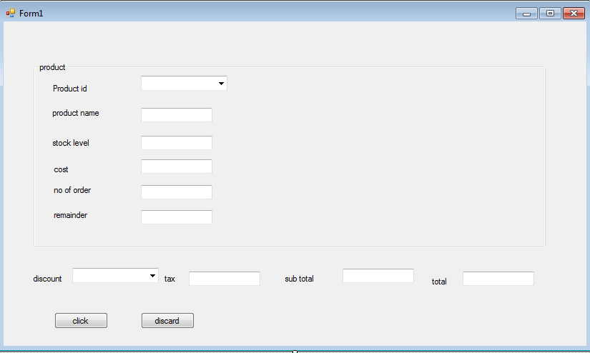

FORM DESIGN

CODING
PublicClassForm1

PrivateSub Form1_Load(ByVal sender As System.Object, ByVal e As System.EventArgs) HandlesMyBase.Load cmbproductid.Items.Add("pid001")
cmbproductid.Items.Add("pid002") cmbproductid.Items.Add("pid003") cmbproductid.Items.Add("pid004")

For d = 0 To 25 Step 5
cmbdiscount.Items.Add(d)
Next EndSub
PrivateSub ComboBox1_SelectedIndexChanged(ByVal sender As System.Object, ByVal e As System.EventArgs) Handles cmbproductid.SelectedIndexChanged

If cmbproductid.Text = "pid001"Then txtproductname.Text = "monitor" txtstocklevel.Text = "100"
txtcost.Text = "20"
ElseIf cmbproductid.Text = "pid002"Then txtproductname.Text = "keyboard" txtstocklevel.Text = "50"
txtcost.Text = "25"
ElseIf cmbproductid.Text = "pid003"Then txtproductname.Text = "cpu"

txtstocklevel.Text = "80"
txtcost.Text = "50"

ElseIf cmbproductid.Text = "pid004"Then txtproductname.Text = " mouse"
txtstocklevel.Text = "50"
txtcost.Text = "20"
EndIf EndSub
PrivateSub txtorder_TextChanged(ByVal sender As System.Object, ByVal e As System.EventArgs) Handles txtorder.TextChanged

txtremainder.Text = Val(txtstocklevel.Text) - Val(txtorder.Text) If txtremainder.Text < 0 Then
MessageBox.Show("limited as been reached") EndIf
EndSub

PrivateSub Button1_Click(ByVal sender As System.Object, ByVal e As System.EventArgs) Handles Button1.Click Dim itax AsDecimal
If cmbdiscount.Text = 0 Then
itax = ((Val(txtcost.Text) * Val(txtorder.Text) * 7.5) / 100) txttax.Text = itax
txtsubtotal.Text = (Val(txtcost.Text) * Val(txtorder.Text)) txttotal.Text = Val(txtsubtotal.Text) + Val(txttax.Text)

ElseIf cmbdiscount.Text = 5 Then
txtsubtotal.Text = (Val(txtcost.Text) * Val(txtorder.Text)) - (((Val(txtcost.Text) * Val(txtorder.Text)) * 5) / 100) itax = ((Val(txtsubtotal.Text) * Val(txtorder.Text) * 7.5) / 100)
txttax.Text = itax
txttotal.Text = (Val(txtsubtotal.Text) + (itax))

ElseIf cmbdiscount.Text = 10 Then
txtsubtotal.Text = (Val(txtcost.Text) * Val(txtorder.Text)) - (((Val(txtcost.Text) * Val(txtorder.Text)) * 10) / 100) itax = ((Val(txtsubtotal.Text) * Val(txtorder.Text) * 7.5) / 100)
txttax.Text = itax
txttotal.Text = (Val(txtsubtotal.Text) + (itax))

ElseIf cmbdiscount.Text = 15 Then
txtsubtotal.Text = (Val(txtcost.Text) * Val(txtorder.Text)) - (((Val(txtcost.Text) * Val(txtorder.Text)) * 15) / 100) itax = ((Val(txtsubtotal.Text) * Val(txtorder.Text) * 7.5) / 100)
txttax.Text = itax
txttotal.Text = (Val(txtsubtotal.Text) + (itax))

ElseIf cmbdiscount.Text = 20 Then
txtsubtotal.Text = (Val(txtcost.Text) * Val(txtorder.Text)) - (((Val(txtcost.Text) * Val(txtorder.Text)) * 20) / 100) itax = ((Val(txtsubtotal.Text) * Val(txtorder.Text) * 7.5) / 100)
txttax.Text = itax
txttotal.Text = (Val(txtsubtotal.Text) + (itax))

ElseIf cmbdiscount.Text = 25 Then
txtsubtotal.Text = (Val(txtcost.Text) * Val(txtorder.Text)) - (((Val(txtcost.Text) * Val(txtorder.Text)) * 25) / 100)
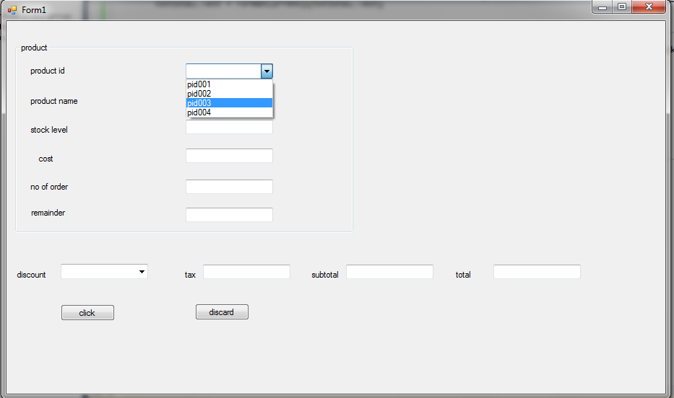

itax = ((Val(txtsubtotal.Text) * Val(txtorder.Text) * 7.5) / 100) txttax.Text = itax
txttotal.Text = (Val(txtsubtotal.Text) + (itax))

EndIf

txttax.Text = FormatCurrency(txttax.Text) txtsubtotal.Text = FormatCurrency(txtsubtotal.Text) txttotal.Text = FormatCurrency(txttotal.Text)

EndSub

PrivateSub Button2_Click(ByVal sender As System.Object, ByVal e As System.EventArgs) Handles Button2.Click txttax.Text = ""
txtsubtotal.Text = " " txttotal.Text = " " cmbdiscount.Text = "0" txtorder.Text = " "
txtremainder.Text = txtremainder.Text + txtorder.Text

EndSub EndClass

OUTPUT
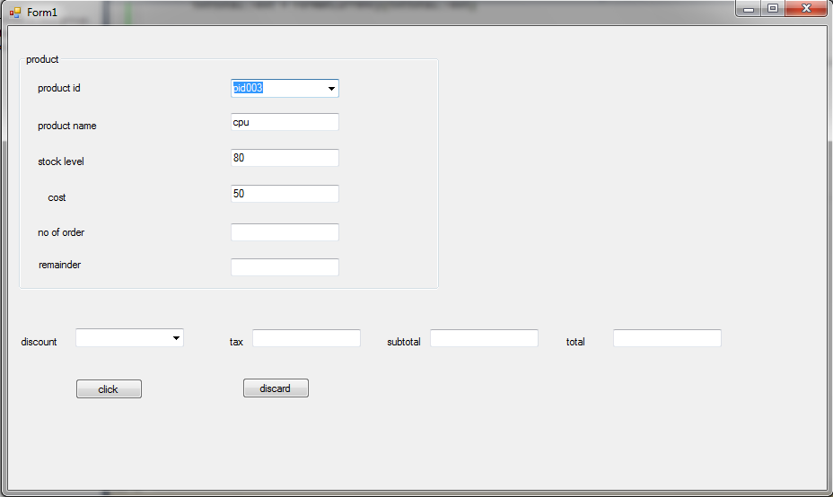
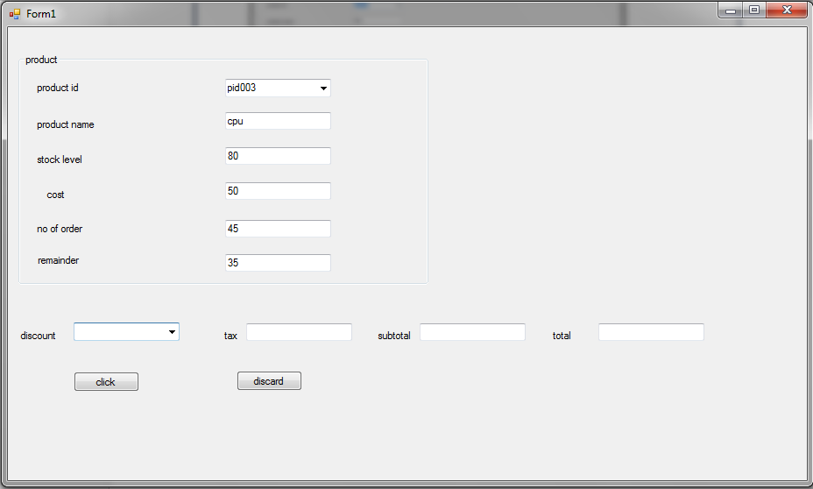

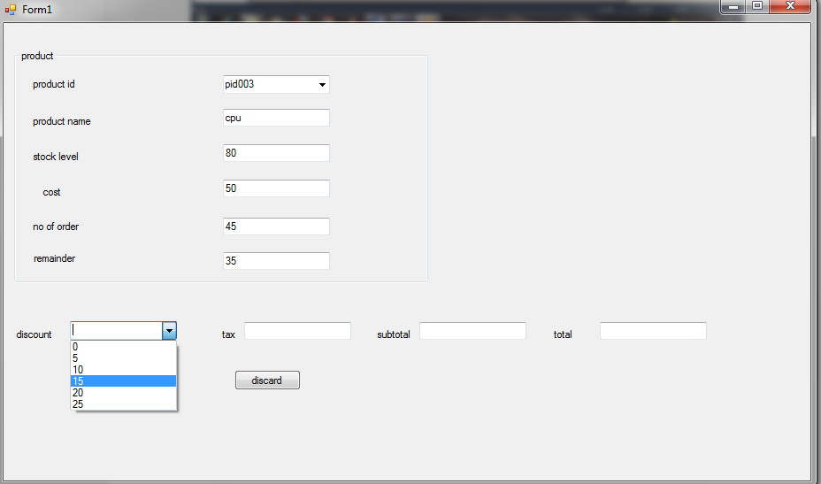
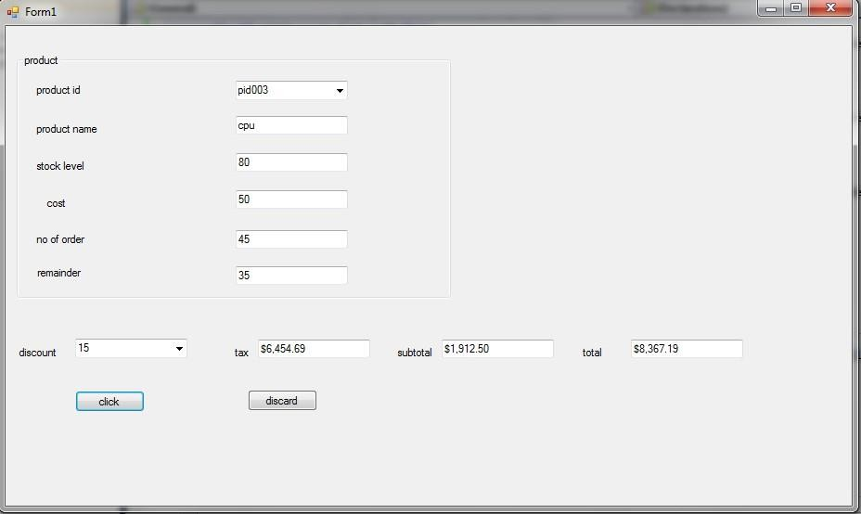

Ex.No:4 EMPLOYEE PAY DETAILS
Date:

AIM:
To create a program for displaying the employe pay details using grid view
ALGORITHM:
Step 1: Start the process
Step 2: Select Start => Microsoft Office => Microsoft Access . And create a blank database with the file name (emp)
Step 3: Go to View Design view and create a table consisting of seven field names with its datatypes respectively
Step 4: Give the details on each data field which should be displayed as output and save those details and close Microsoft Access
Step 5: Then select Start Programs Microsoft Visual Studio
Step 6: It opens a dialog box in that select New project icon Windows form application specifying the file name (emp) then click ok
Step 7:Select Data Data grid view Add Project Data Source My Computer Libraries Documents emp
Step 8:Click on the options Table 1 details.Drag and Drop the selected details below the datagrid view
Step 9:Stop the process
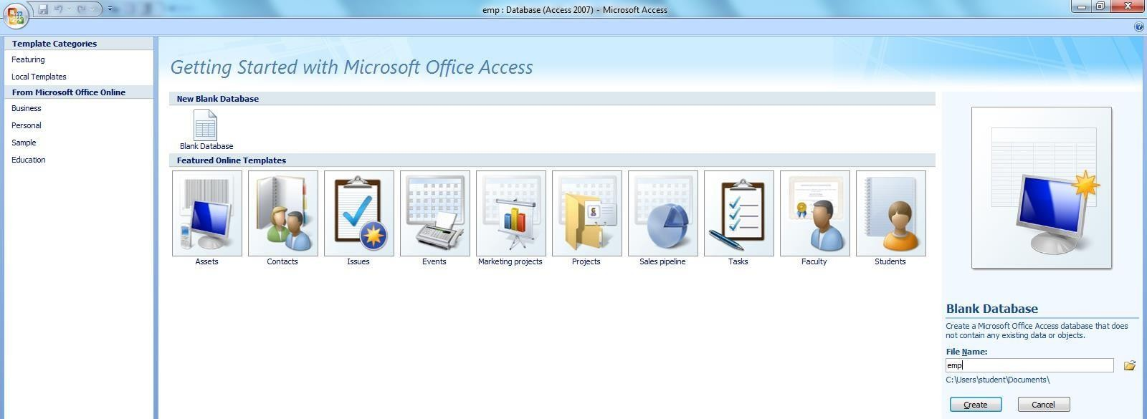
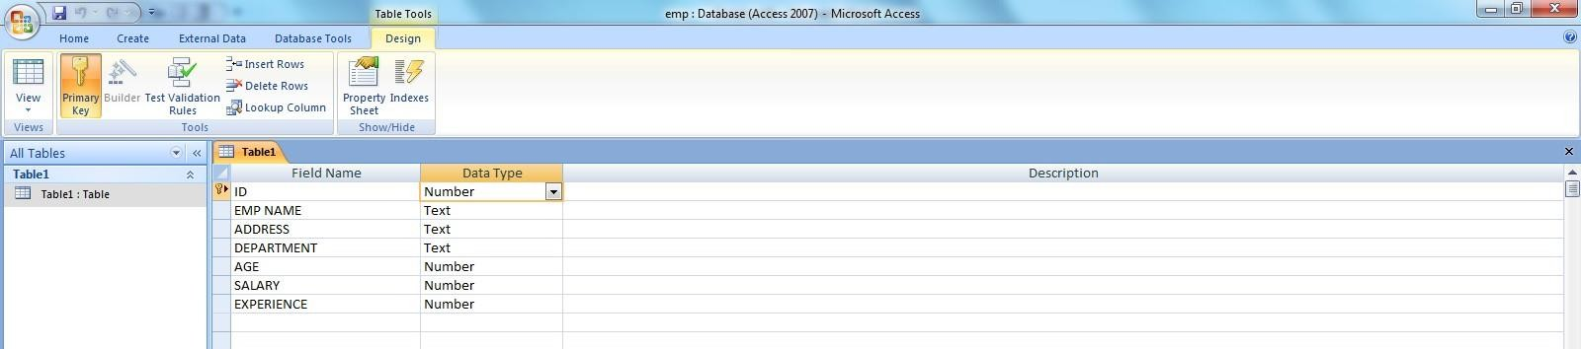

DESIGN WINDOW

DESIGN VIEW
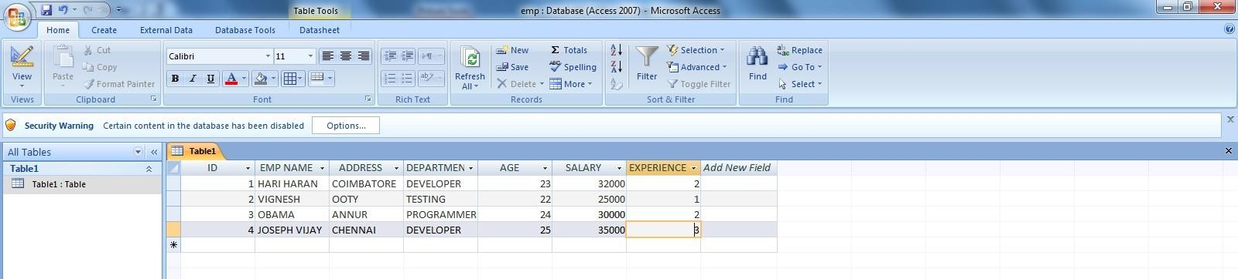
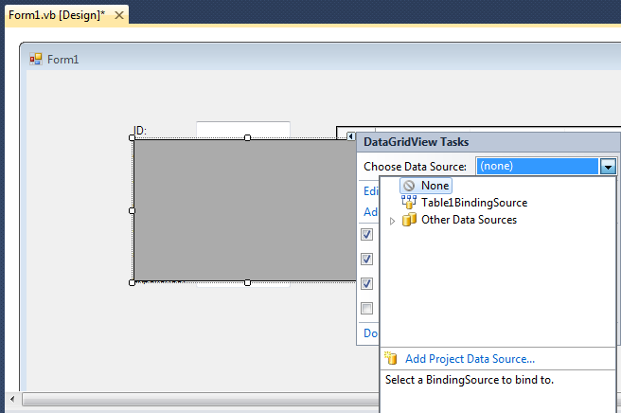

DATASHEET VIEW

VISUAL STUDIO DESIGN WINDOW
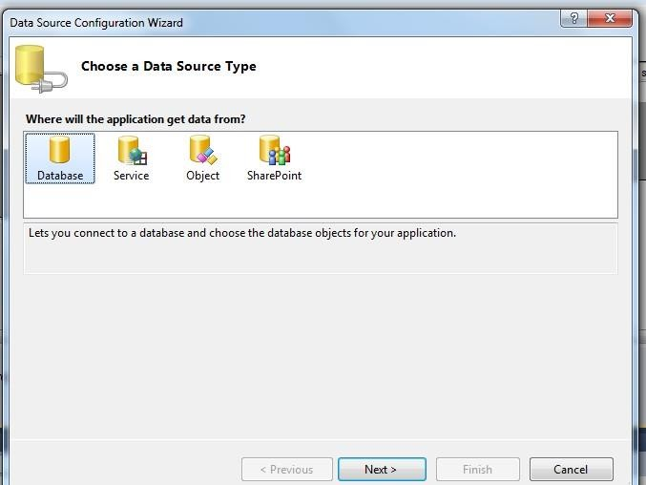
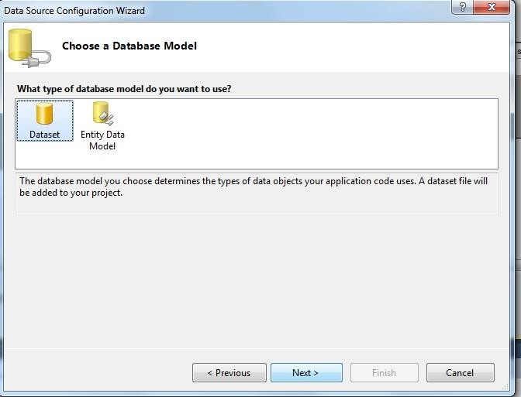

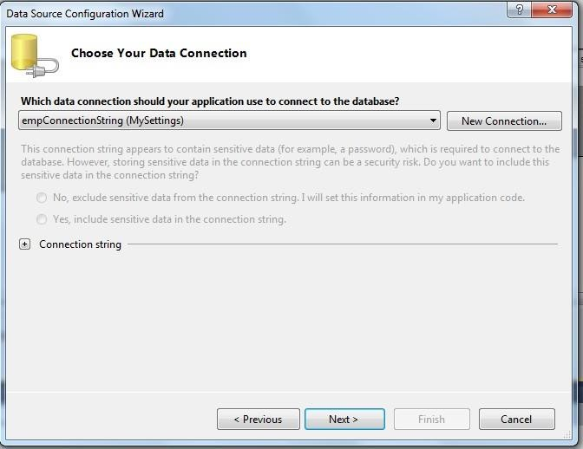
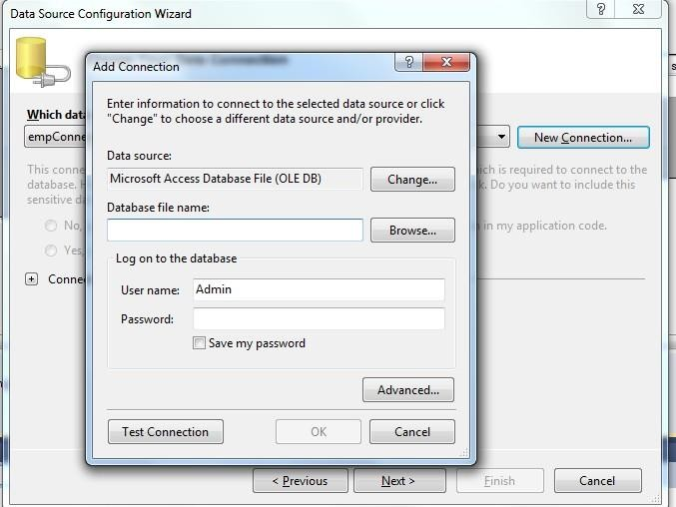

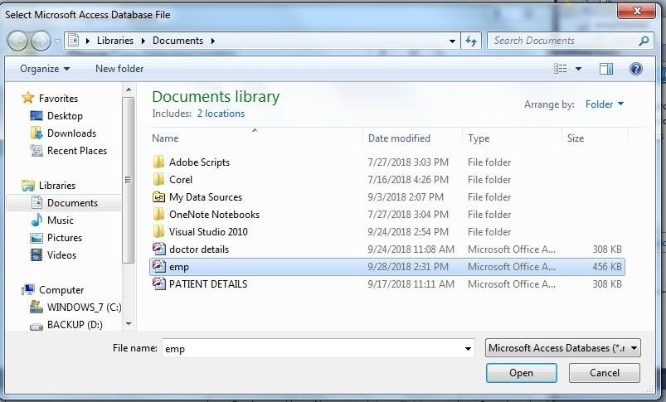
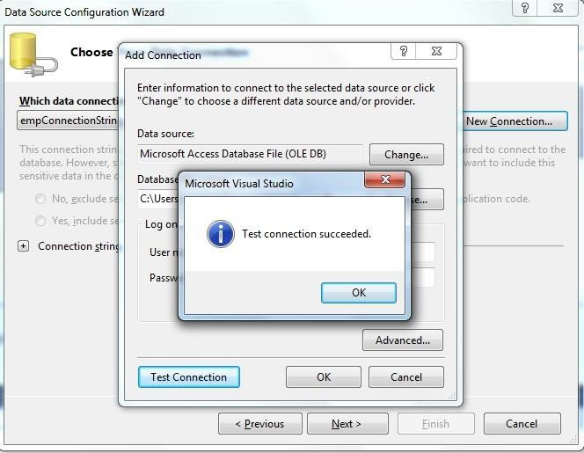

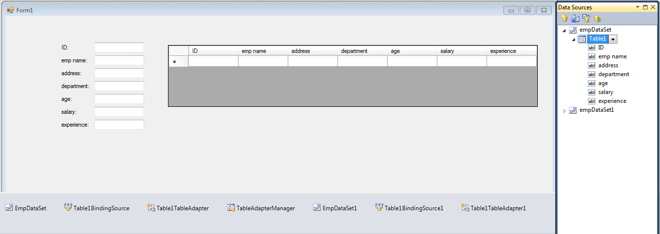
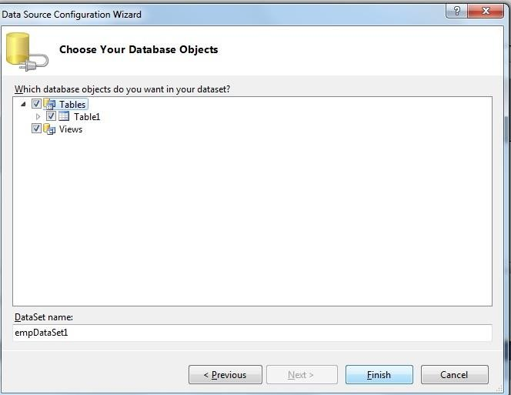

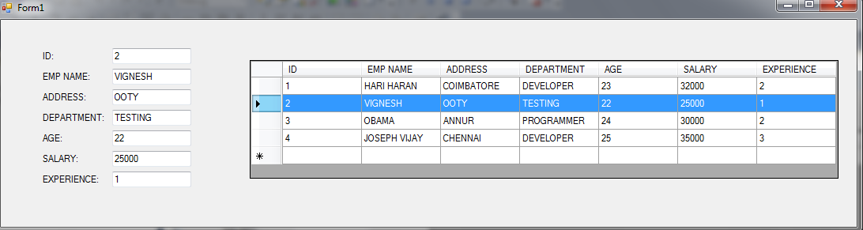

OUTPUT

Ex.No: 5 NOTEPAD APPLICATION

Date:

AIM:
To create a notepad application using implementing menu’s

ALGORITHM:
Step 1:Start the process
Step 2: Select start =>programs =>Microsoft visual studio
Step 3: It opens a dialog box in that select New project icon and select windows form application & specify the file name .then click OK
Step 4: After step 3, It opens a new form along the toolbox into the form
Step 5:Start building a menu, click inside the area that says”Type Here” and Add the menu anme& press enter key
Step 6:Follow step 5 add the following menu’s
=> file menu with submenu’s New= opens a new text file
Open= opens the existing text file using open file dialog1 Save=saves the new text file with content using save file dialog Exit= Exits from text file
=>Edit menu with sub menu’s
Cut Copy Paste
(above menus are used to cut, copy the text & paste it to new location) Undo= To reverse the last action performed

=>Format menu with submenu’s
Font =opens a font dialog box, using this font type, size. Color=Used ton change the color using color dialog box
=>help menu with submenu’s
About =help content can be added as a supporting file

Step 7: Stop the process
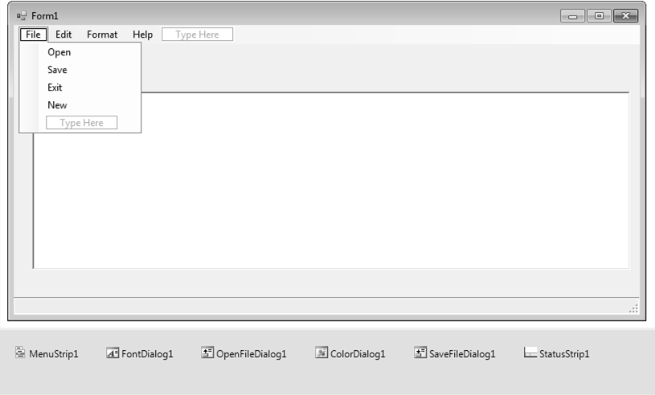
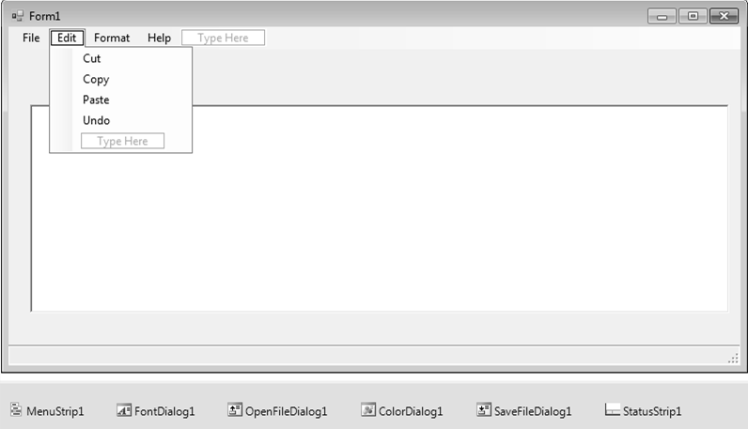

FORM DESIGN
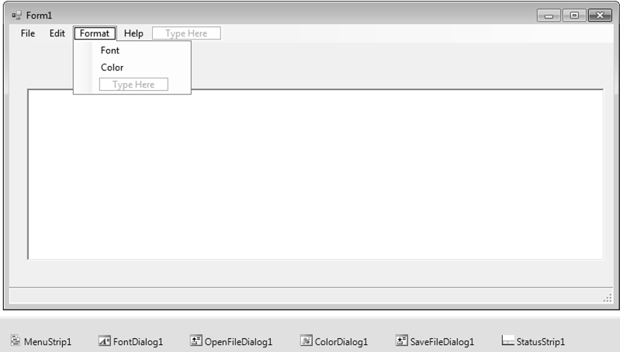
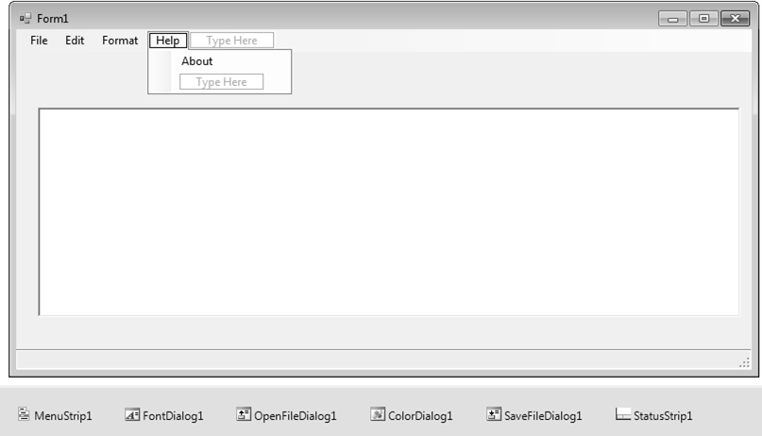

CODING
Public Class Form1

Private Sub NewToolStripMenuItem_Click(ByVal sender As System.Object, ByVal e As System.EventArgs) Handles NewToolStripMenuItem.Click
RichTextBox1.Text = " " End Sub

Private Sub OpenToolStripMenuItem_Click(ByVal sender As System.Object, ByVal e As System.EventArgs) Handles OpenToolStripMenuItem.Click
Me.OpenFileDialog1.DefaultExt = "richtextformat/*.rtf" Me.OpenFileDialog1.Filter = "textfiles|*.txt|all files|*.*" Me.OpenFileDialog1.ShowDialog() Me.RichTextBox1.LoadFile(Me.OpenFileDialog1.FileName,
RichTextBoxStreamType.PlainText)
Me.Text = (Me.OpenFileDialog1.FileName) End Sub
Private Sub SaveToolStripMenuItem_Click(ByVal sender As System.Object, ByVal e As System.EventArgs) Handles SaveToolStripMenuItem.Click
Me.SaveFileDialog1.DefaultExt = "richtextformat/*.rtf" Me.SaveFileDialog1.Filter = "textfiles|*.txt|all files|*.*" Me.SaveFileDialog1.ShowDialog() Me.RichTextBox1.SaveFile(Me.SaveFileDialog1.FileName,
RichTextBoxStreamType.PlainText)
Me.Text = (Me.SaveFileDialog1.FileName) End Sub
Private Sub CutToolStripMenuItem_Click(ByVal sender As System.Object, ByVal e As System.EventArgs) Handles CutToolStripMenuItem.Click
Me.RichTextBox1.Cut() End Sub
Private Sub CopyToolStripMenuItem_Click(ByVal sender As System.Object, ByVal e As System.EventArgs) Handles CopyToolStripMenuItem.Click

Me.RichTextBox1.Copy() End Sub
Private Sub PasteToolStripMenuItem_Click(ByVal sender As System.Object, ByVal e As System.EventArgs) Handles PasteToolStripMenuItem.Click
Me.RichTextBox1.Paste() End Sub
Private Sub UndoToolStripMenuItem_Click(ByVal sender As System.Object, ByVal e As System.EventArgs) Handles UndoToolStripMenuItem.Click
Me.RichTextBox1.Undo() End Sub
Private Sub ExitToolStripMenuItem_Click(ByVal sender As System.Object, ByVal e As System.EventArgs) Handles ExitToolStripMenuItem.Click
Me.Close() End Sub

Private Sub FontToolStripMenuItem_Click(ByVal sender As System.Object, ByVal e As System.EventArgs) Handles FontToolStripMenuItem.Click
Me.FontDialog1.ShowDialog() Me.RichTextBox1.Font = Me.FontDialog1.Font
End Sub

Private Sub ColorToolStripMenuItem_Click(ByVal sender As System.Object, ByVal e As System.EventArgs) Handles ColorToolStripMenuItem.Click
Me.ColorDialog1.ShowDialog() Me.RichTextBox1.ForeColor = (Me.ColorDialog1.Color)
End Sub

Private Sub AboutToolStripMenuItem_Click(ByVal sender As System.Object, ByVal e As System.EventArgs) Handles AboutToolStripMenuItem.Click
MsgBox("Developed by 3rd bsc-cs") End Sub
End Class
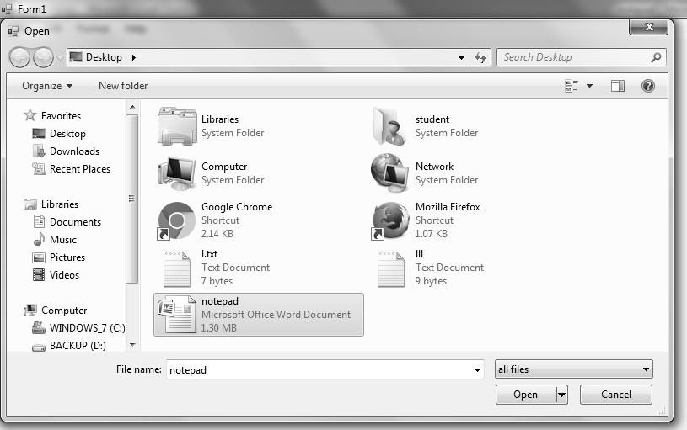

OUTPUT
NOTEPAD APPLICATION FILE =>OPEN
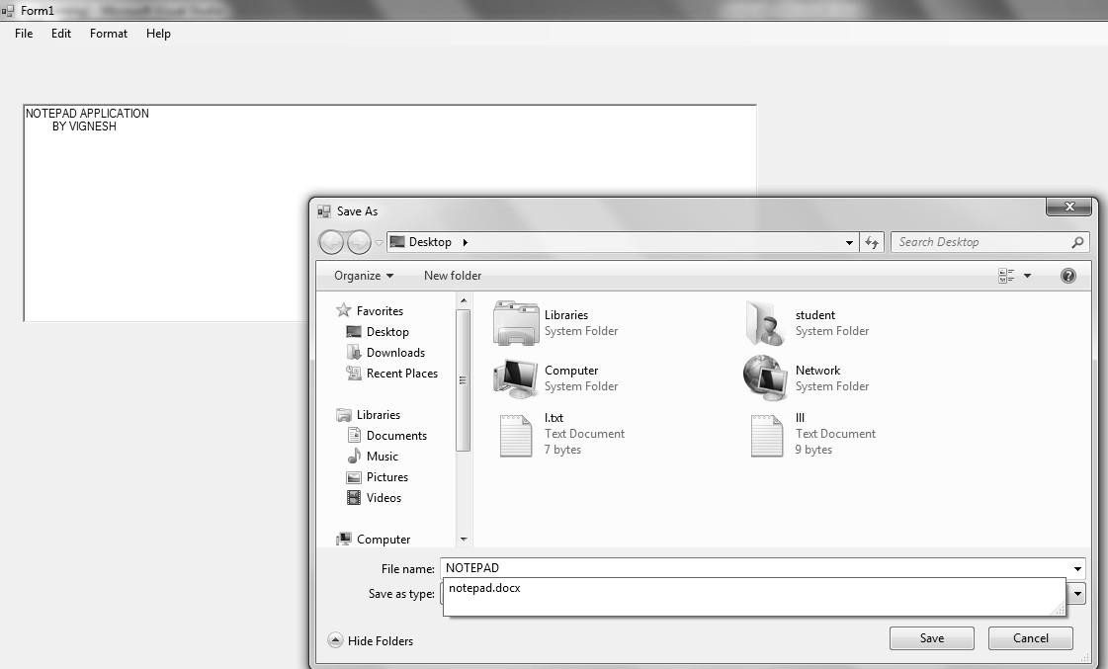
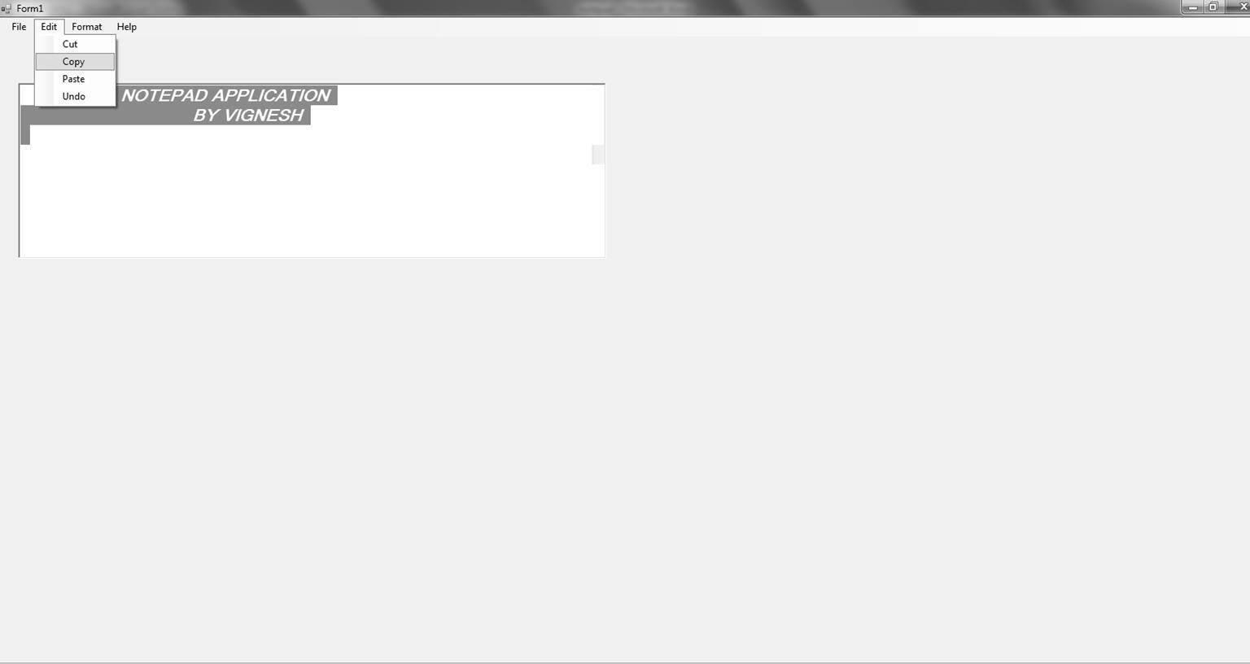

FILE=>SAVE

EDIT=>COPY
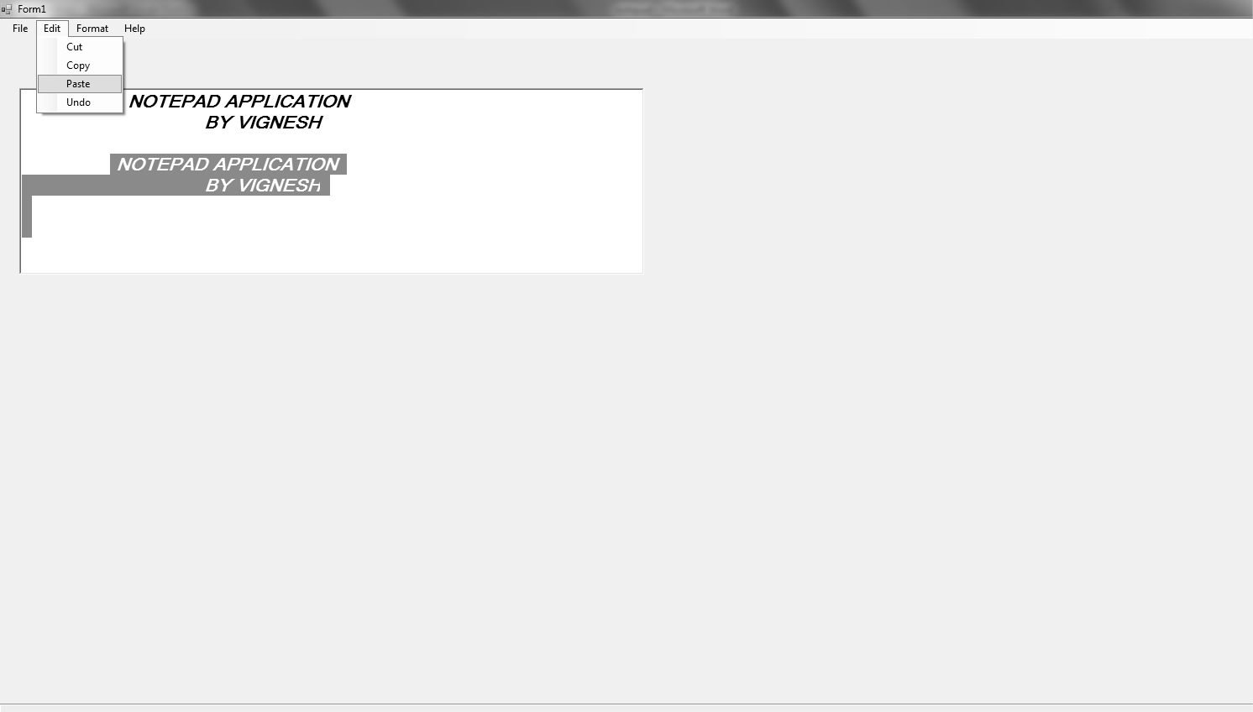
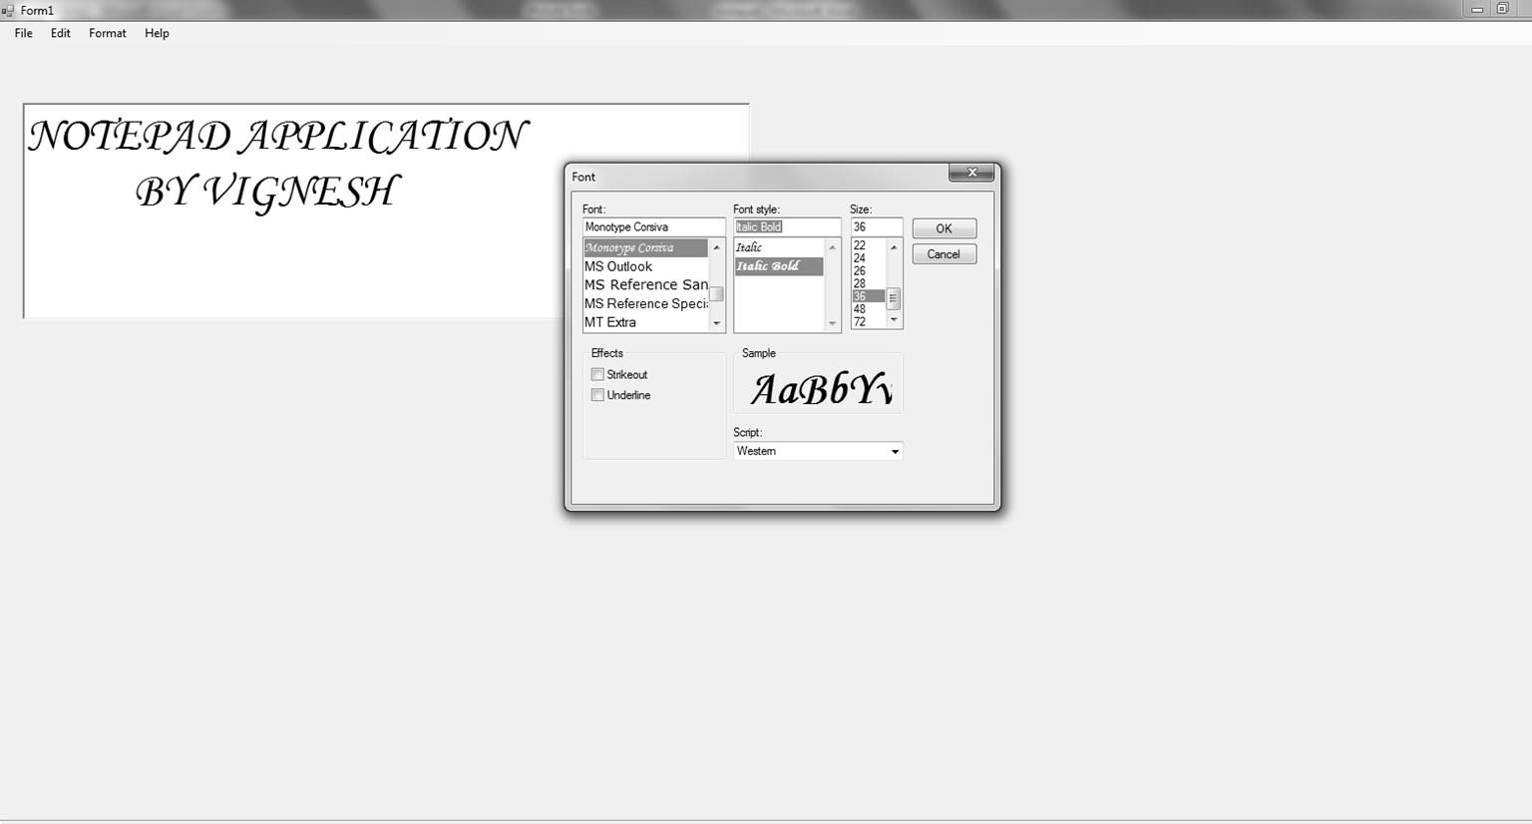

EDIT=>PASTE

FORMAT=>FONT
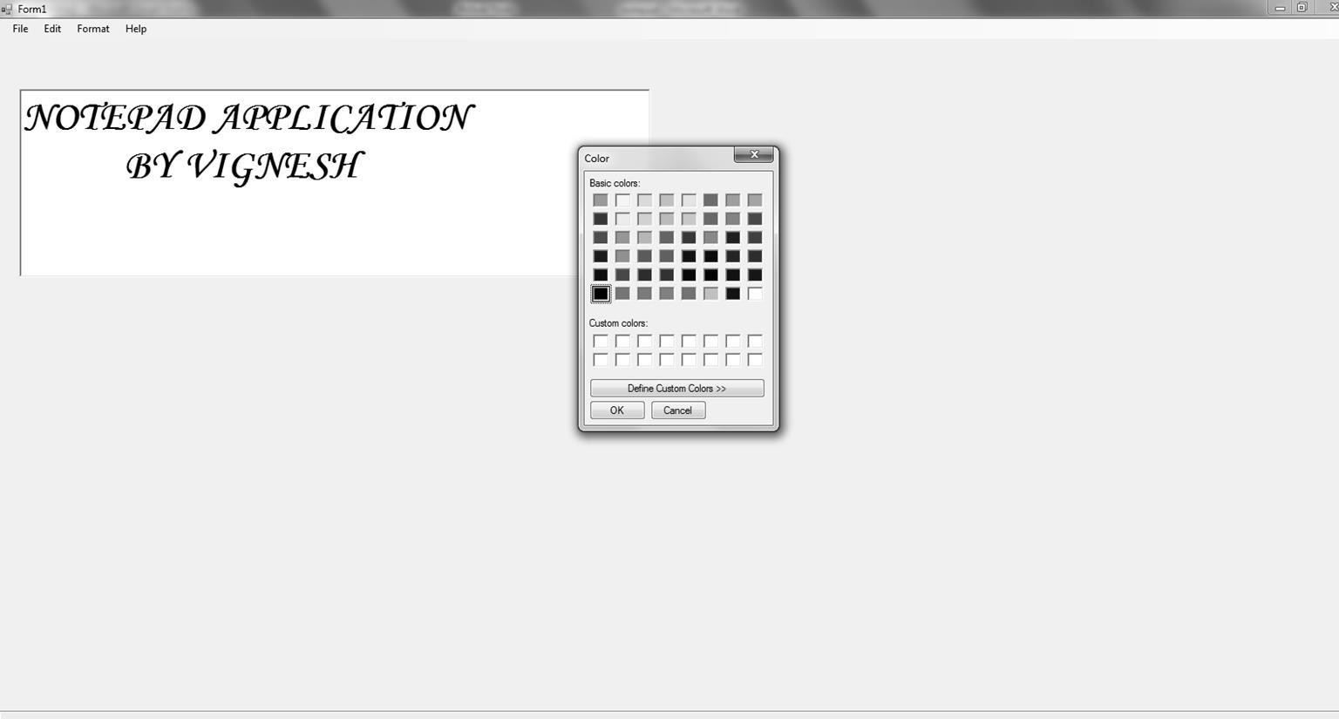

FORMAT=>COLOR

Ex.No: 6 HOSPITAL MANAGEMENT
Date:

AIM:
To create a program for hospital management and generate crystal reports ALGORITHM:
Step 1:start the process
Step 2:select start Microsoft office Microsoft access . And create a blank database with the file name (patient)
Step 3: Go to View Design view and create a table consisting of field names with its datatypes respectively
Step 4: Give the details on each data field which should be displayed as output and save those details and close Microsoft Access
Step 5:Create another blank database with the file name (doctor).Repeat step 3 and step 4 .
Save those details and close Microsoft Access
Step 6: Then select Start Programs Microsoft Visual Studio
Step 7: It opens a dialog box in that select New project icon Windows form application then click ok
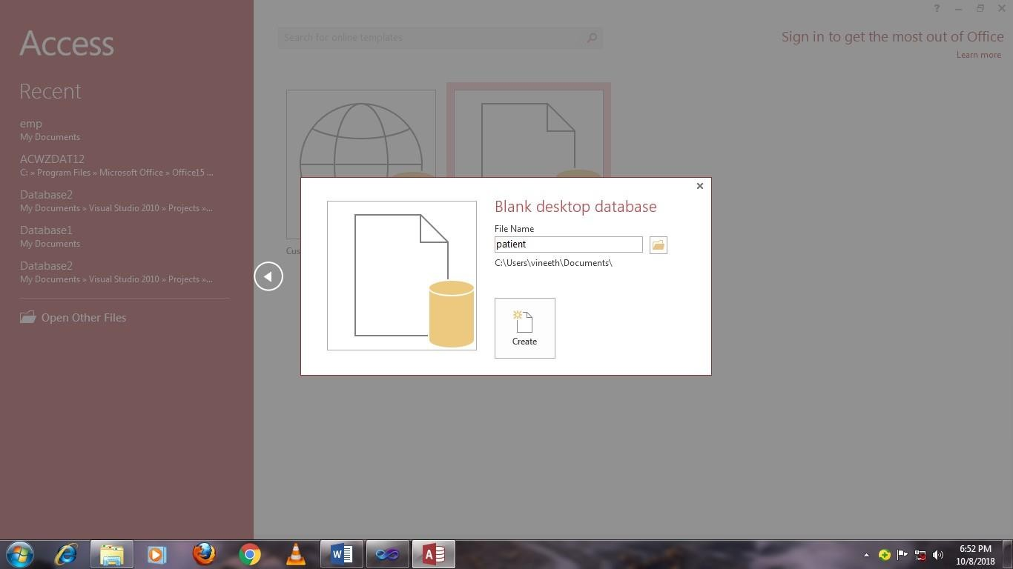
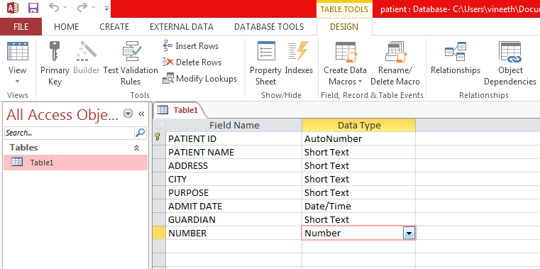

MS ACCESS
=>PATIENT DETAILS

=>DESIGN VIEW
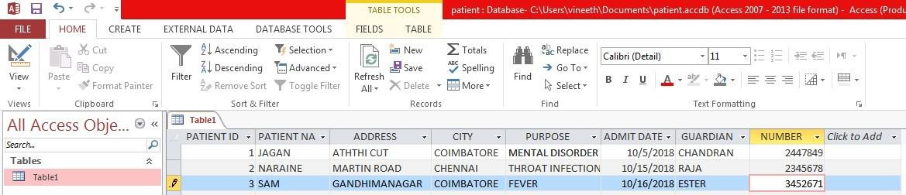
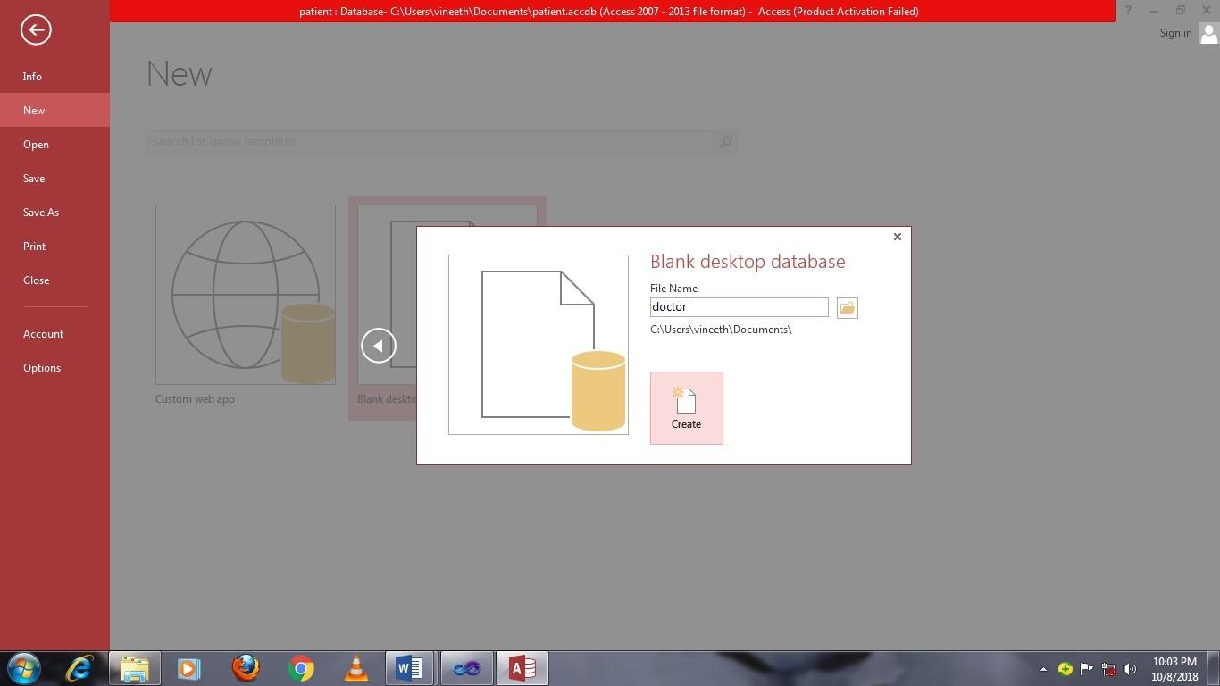

=>DATASHEET VIEW

=>DOCTOR DETAILS
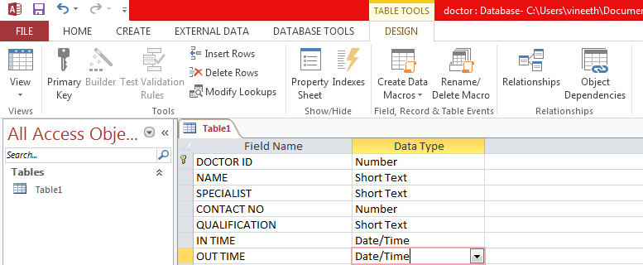
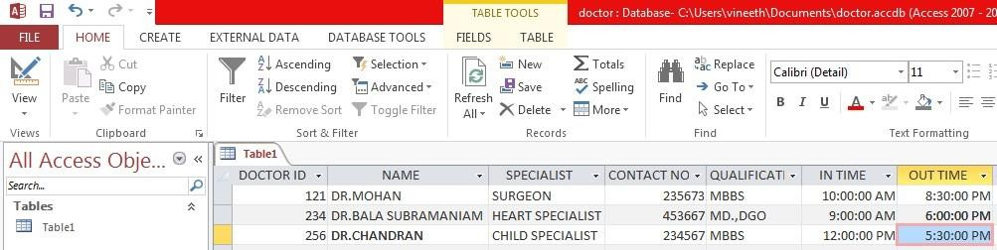

=>DESIGN VIEW

=>DATASHEET VIEW
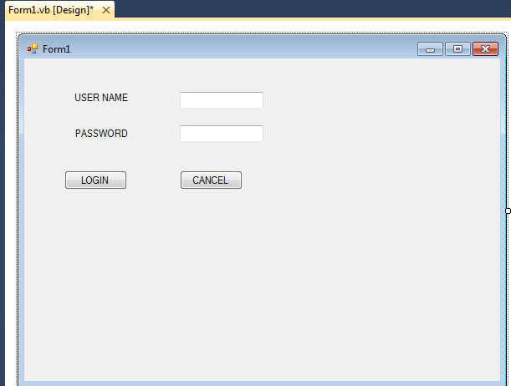
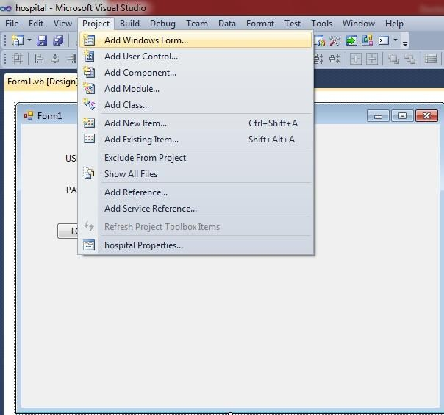

VISUAL STUDIO
=>DESIGN WINDOW

=>ADD NEW FORM
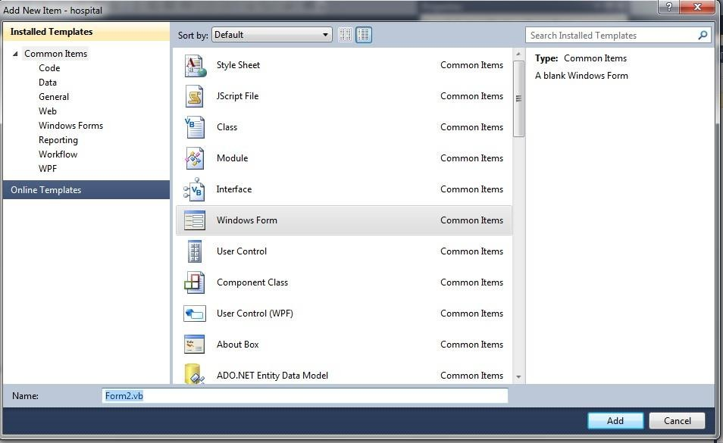
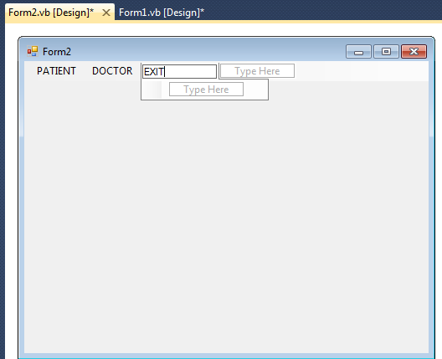

FORM 2
=>DRAG AND DROP MENU STRIP
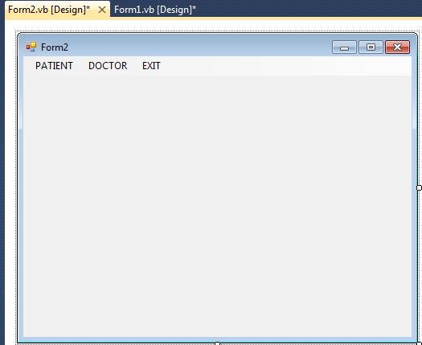

FORM 3
=>ADD NEW FORM
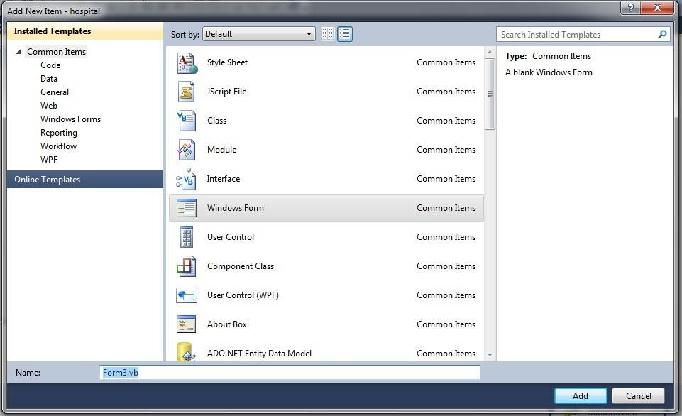
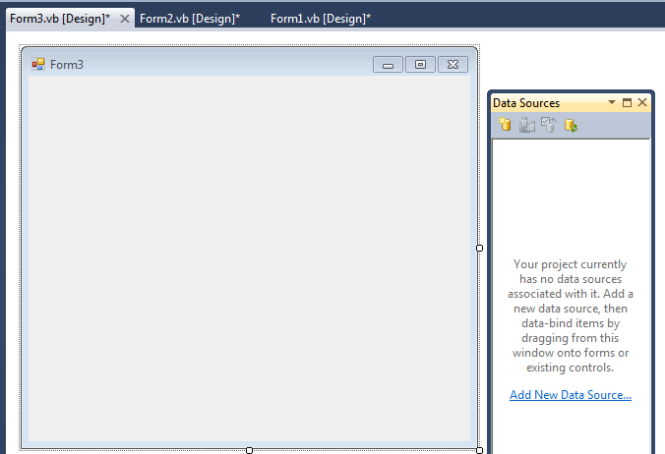

=>CONNECT DATA SOURCE
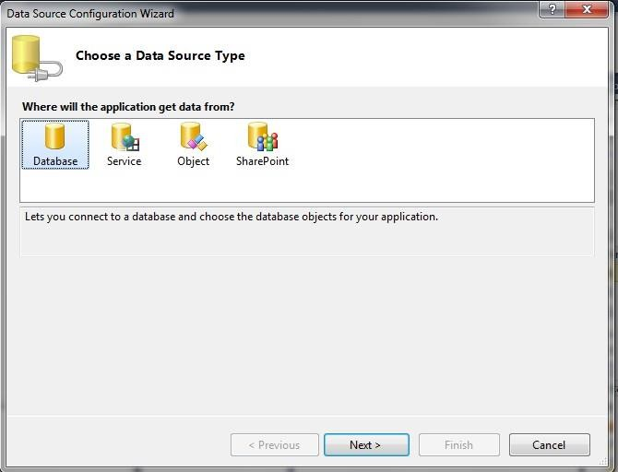
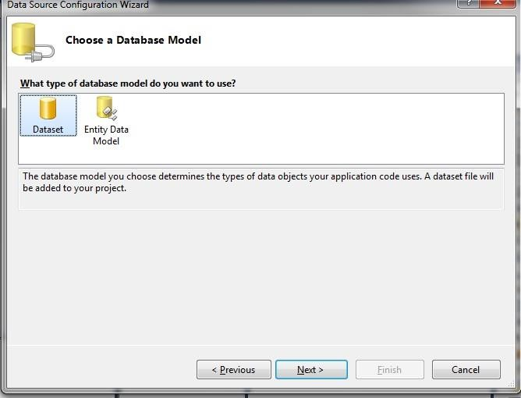

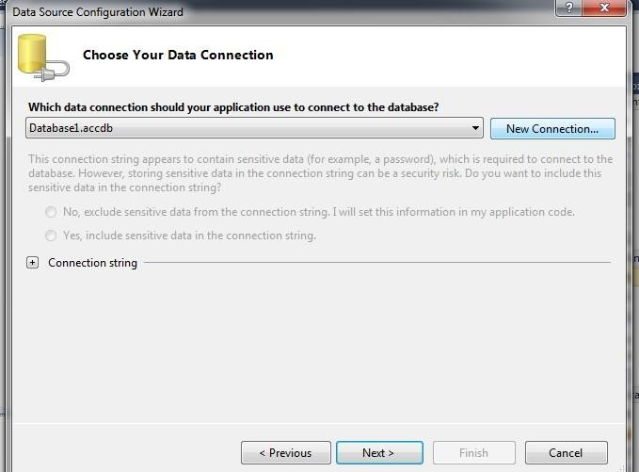
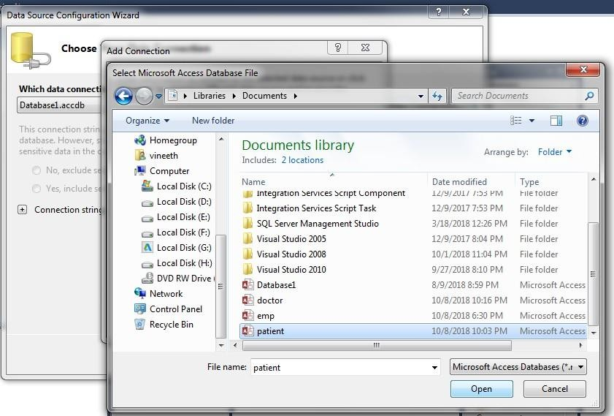

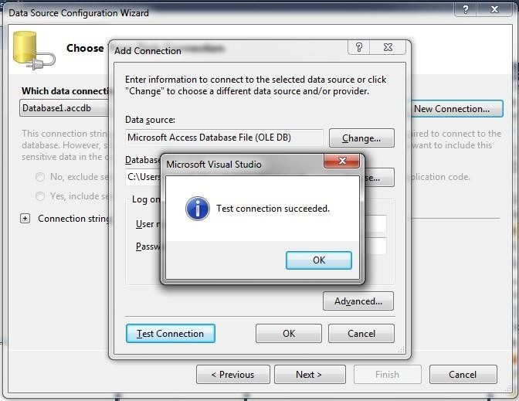
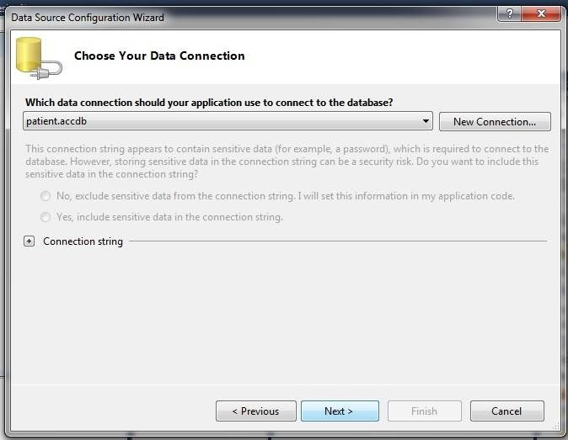

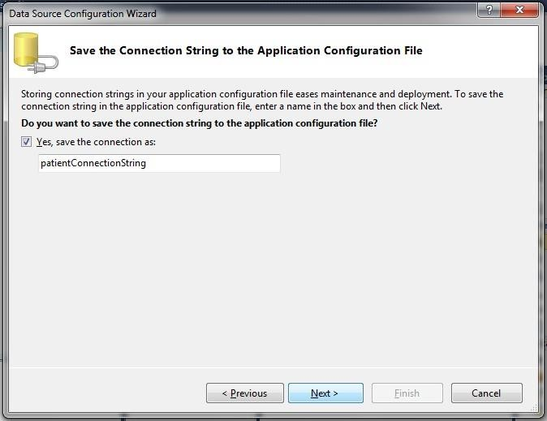
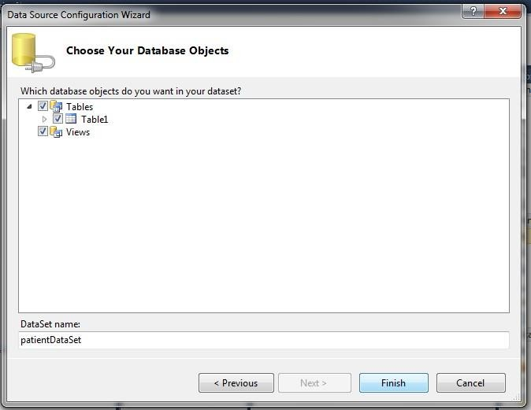

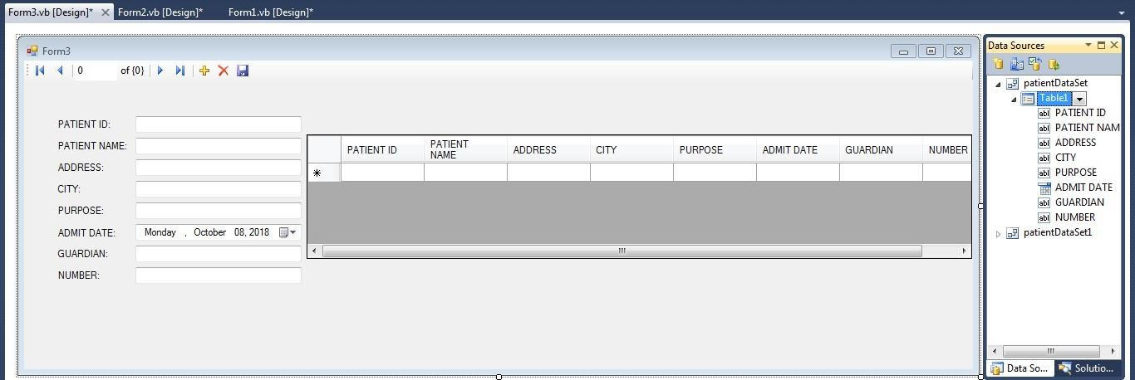

FORM 4
=>ADD NEW FORM
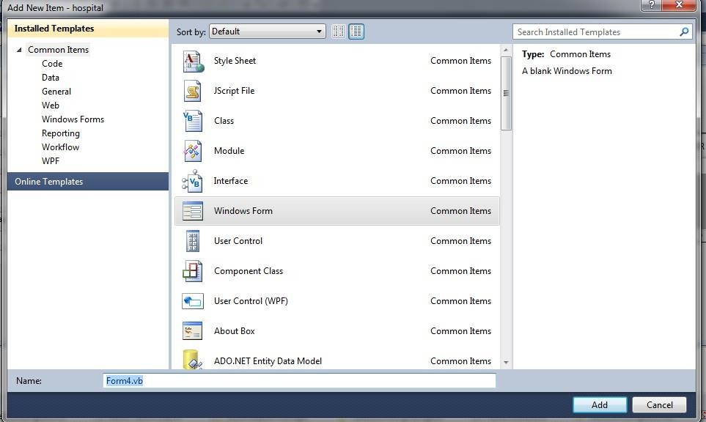
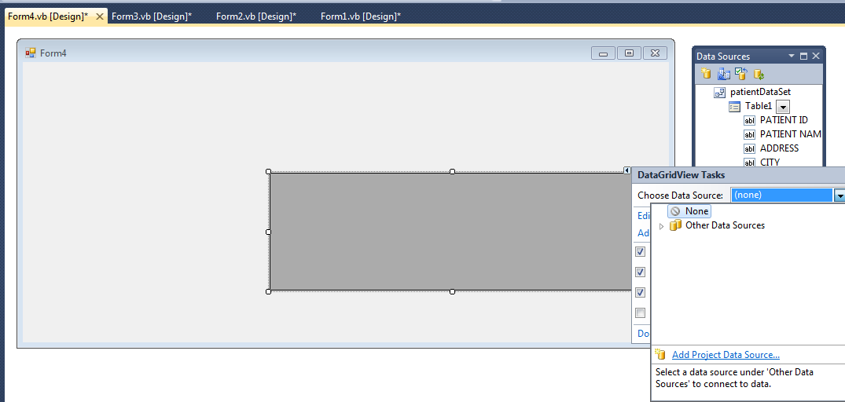

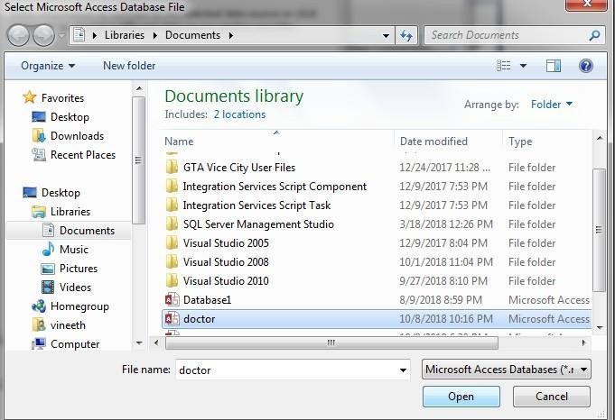

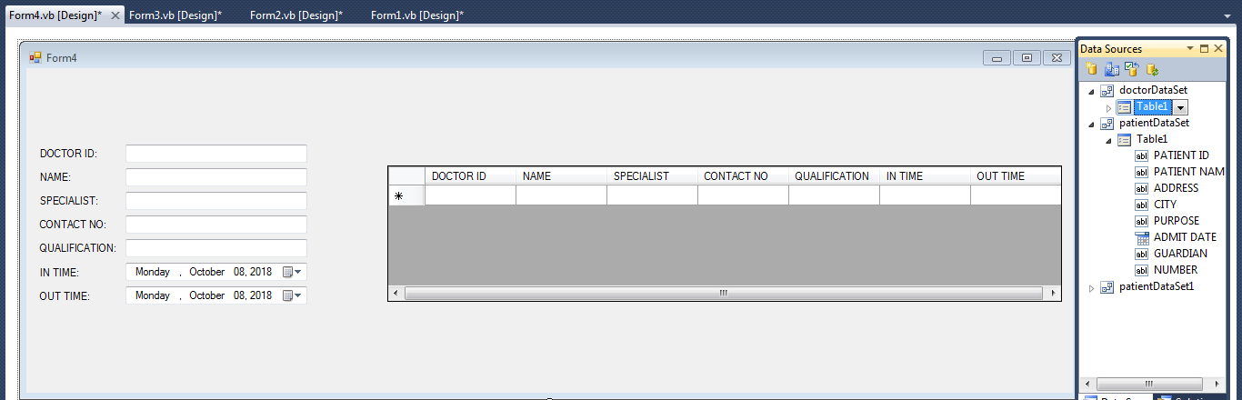

CODING
PublicClassForm1

PrivateSub Button1_Click(ByVal sender AsSystem.Object, ByVal e AsSystem.EventArgs) Handles Button1.Click Form2.Show()
EndSub

PrivateSub Button2_Click(ByVal sender AsSystem.Object, ByVal e AsSystem.EventArgs) Handles Button2.Click End
EndSub EndClass
‘FORM 2’
PublicClassForm2

PrivateSubPATIENTToolStripMenuItem_Click(ByVal sender AsSystem.Object, ByVal e AsSystem.EventArgs) HandlesPATIENTToolStripMenuItem.Click
Form3.Show() EndSub

PrivateSubDOCTORToolStripMenuItem_Click(ByVal sender AsSystem.Object, ByVal e AsSystem.EventArgs) HandlesDOCTORToolStripMenuItem.Click
Form4.Show() EndSub
PrivateSubEXITToolStripMenuItem_Click(ByVal sender AsSystem.Object, ByVal e AsSystem.EventArgs) HandlesEXITToolStripMenuItem.Click
End EndSub EndClass
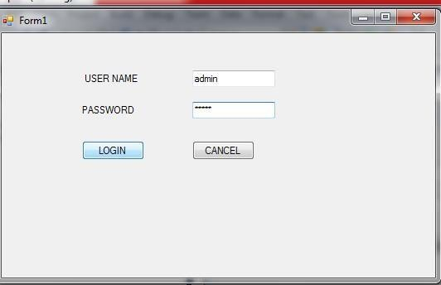
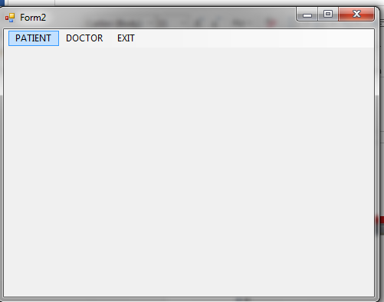
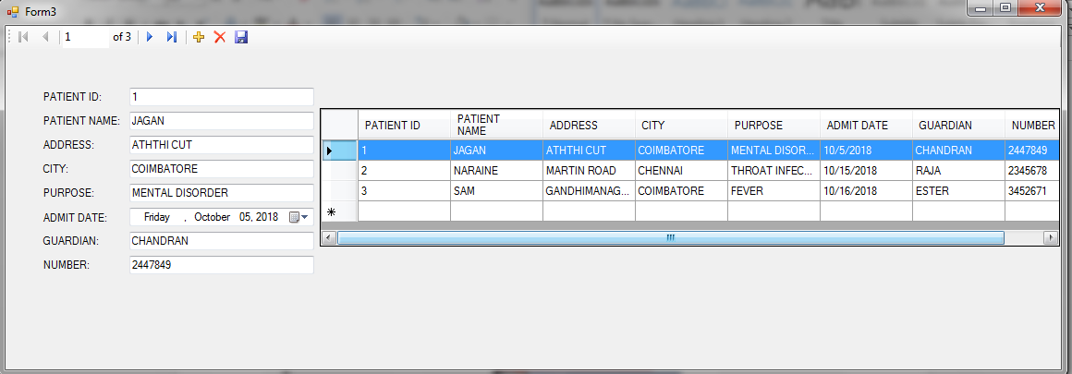

OUTPUT
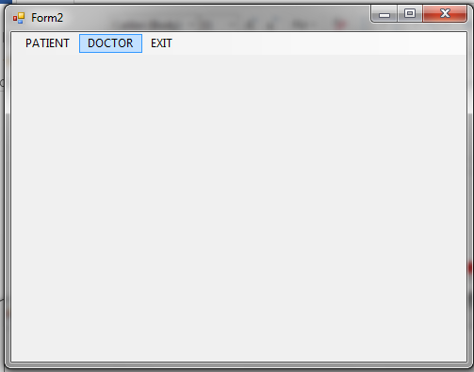
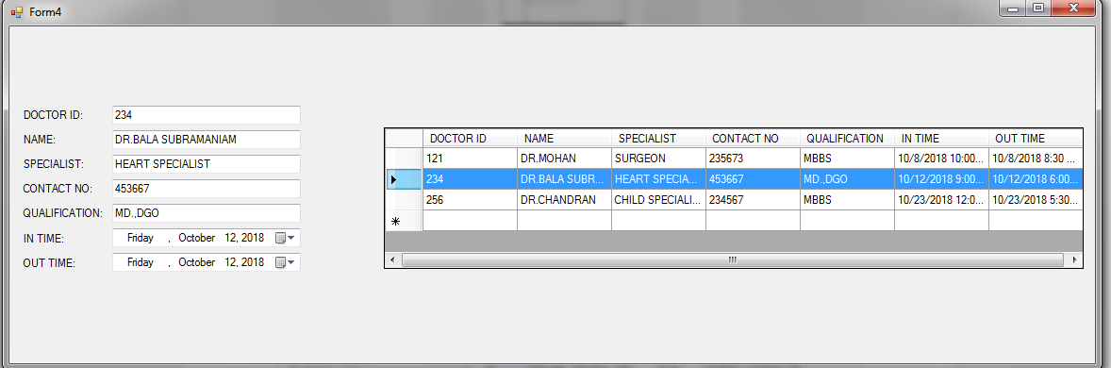
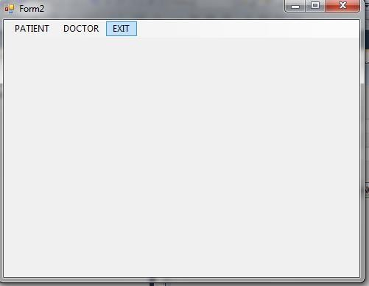

Ex.No:7 FONT APPLICATION
Date:

AIM:
To changing the font applications of the text.

ALGORITHM:
STEP 1: Start the Program.
STEP 2: Start Microsoft Visual studio2008 New website Add Web form Visual C#.
STEP 3: Write the ASP.NET Code to change the font of the text in the applications.

STEP 4: Execute the program and Display the Result in the Screen.
STEP 5: Stop the Program.
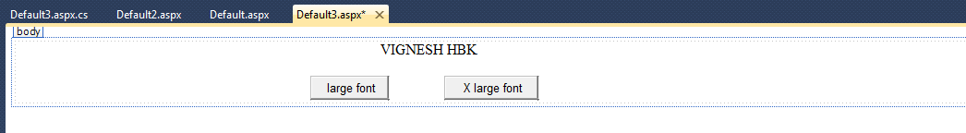
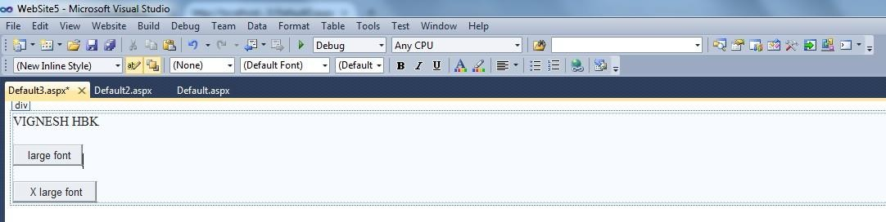

DESIGN VIEW

CODING
using System;
using System.Collections.Generic; using System.Linq;
using System.Web; using System.Web.UI;
using System.Web.UI.WebControls;

public partial class Default3 : System.Web.UI.Page
{
protected void Page_Load(object sender, EventArgs e)
{

}
protected void Button1_Click(object sender, EventArgs e)
{
Label1.Font.Size = FontUnit.Large;
}
protected void Button2_Click(object sender, EventArgs e)
{
Label1.Font.Size = FontUnit.XLarge;
}
}
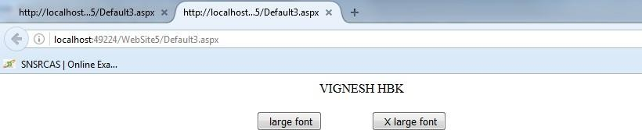
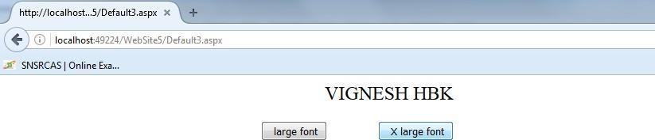
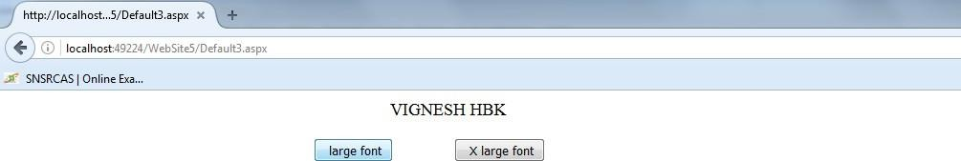

OUTPUT

